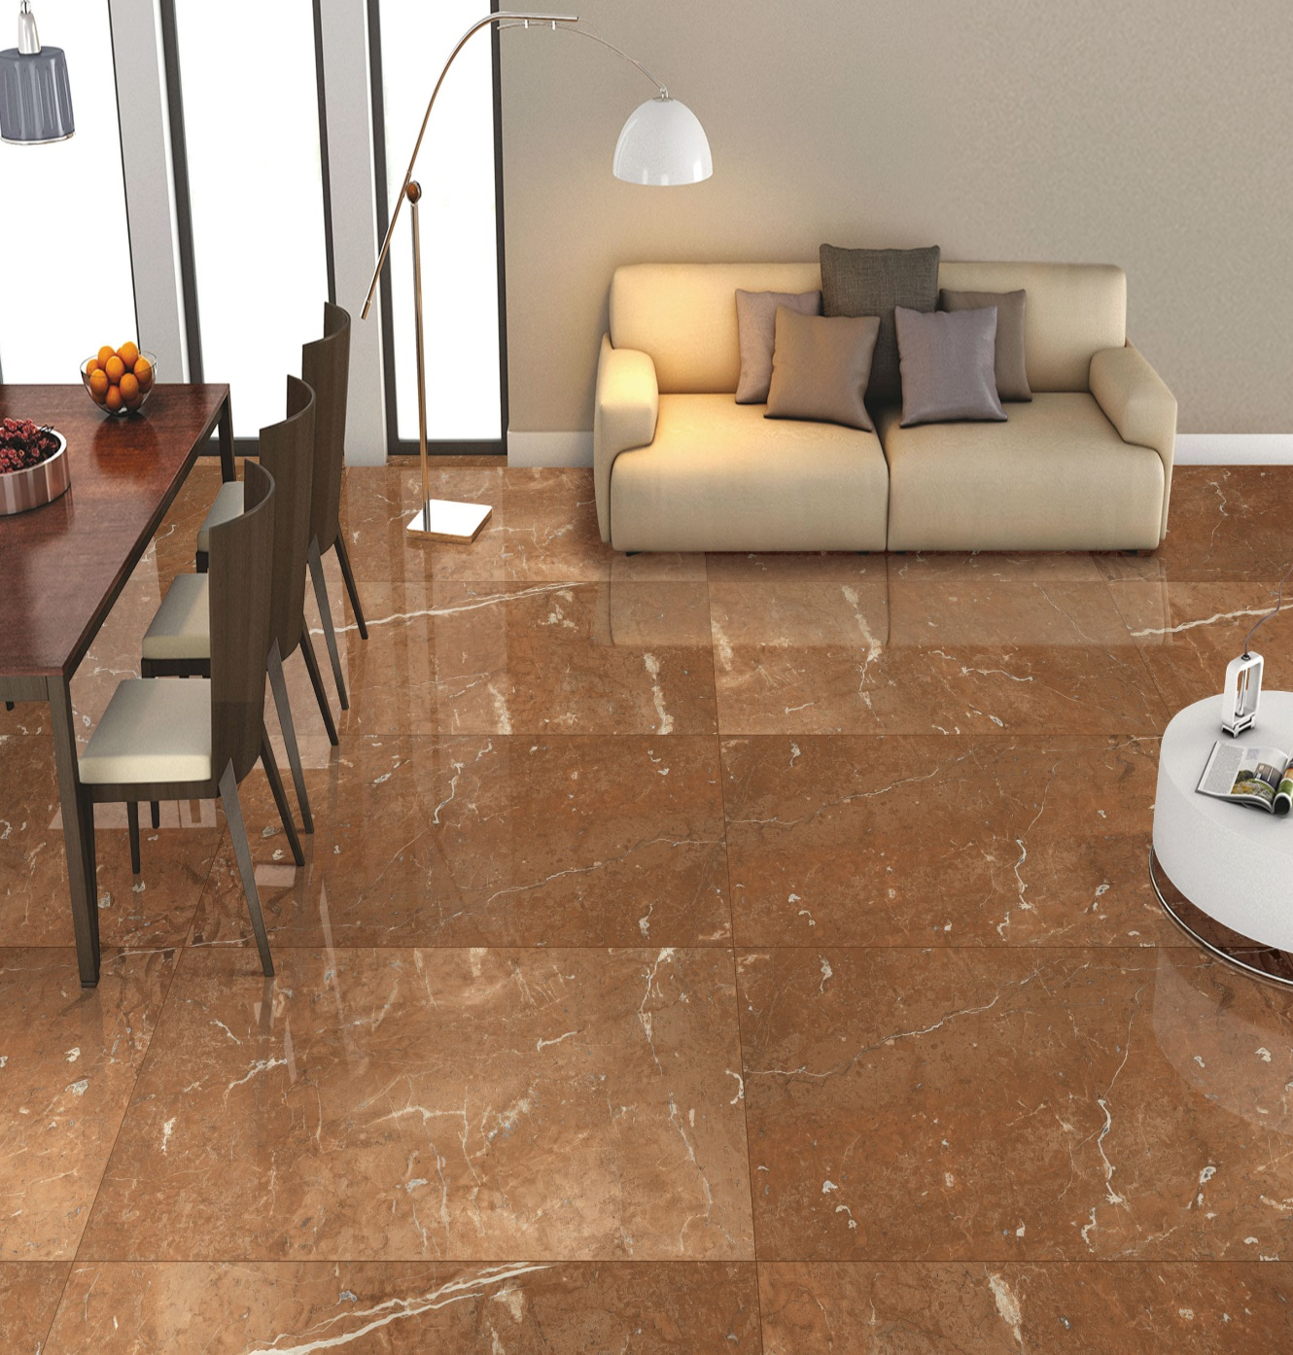



**Ceramic Tile**

Cera’s Limited

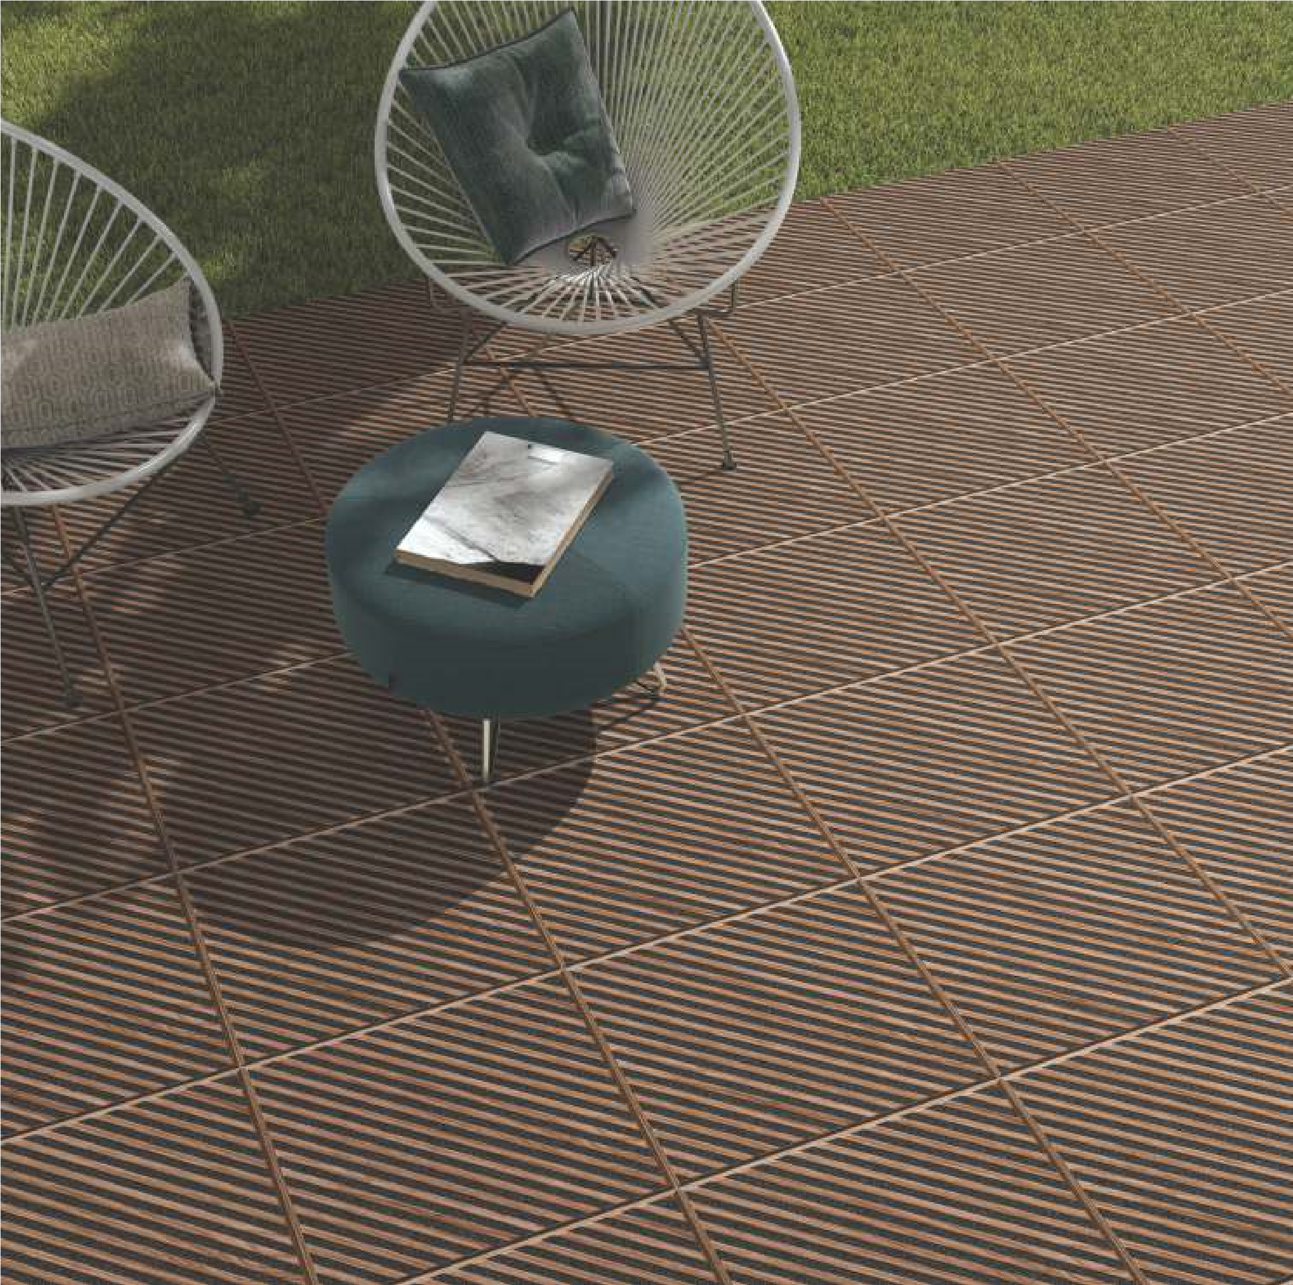

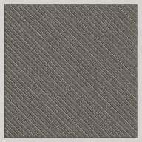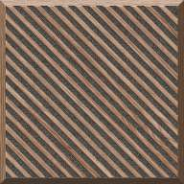

Concrete Gris

Concrete Nero

Concrete Wood

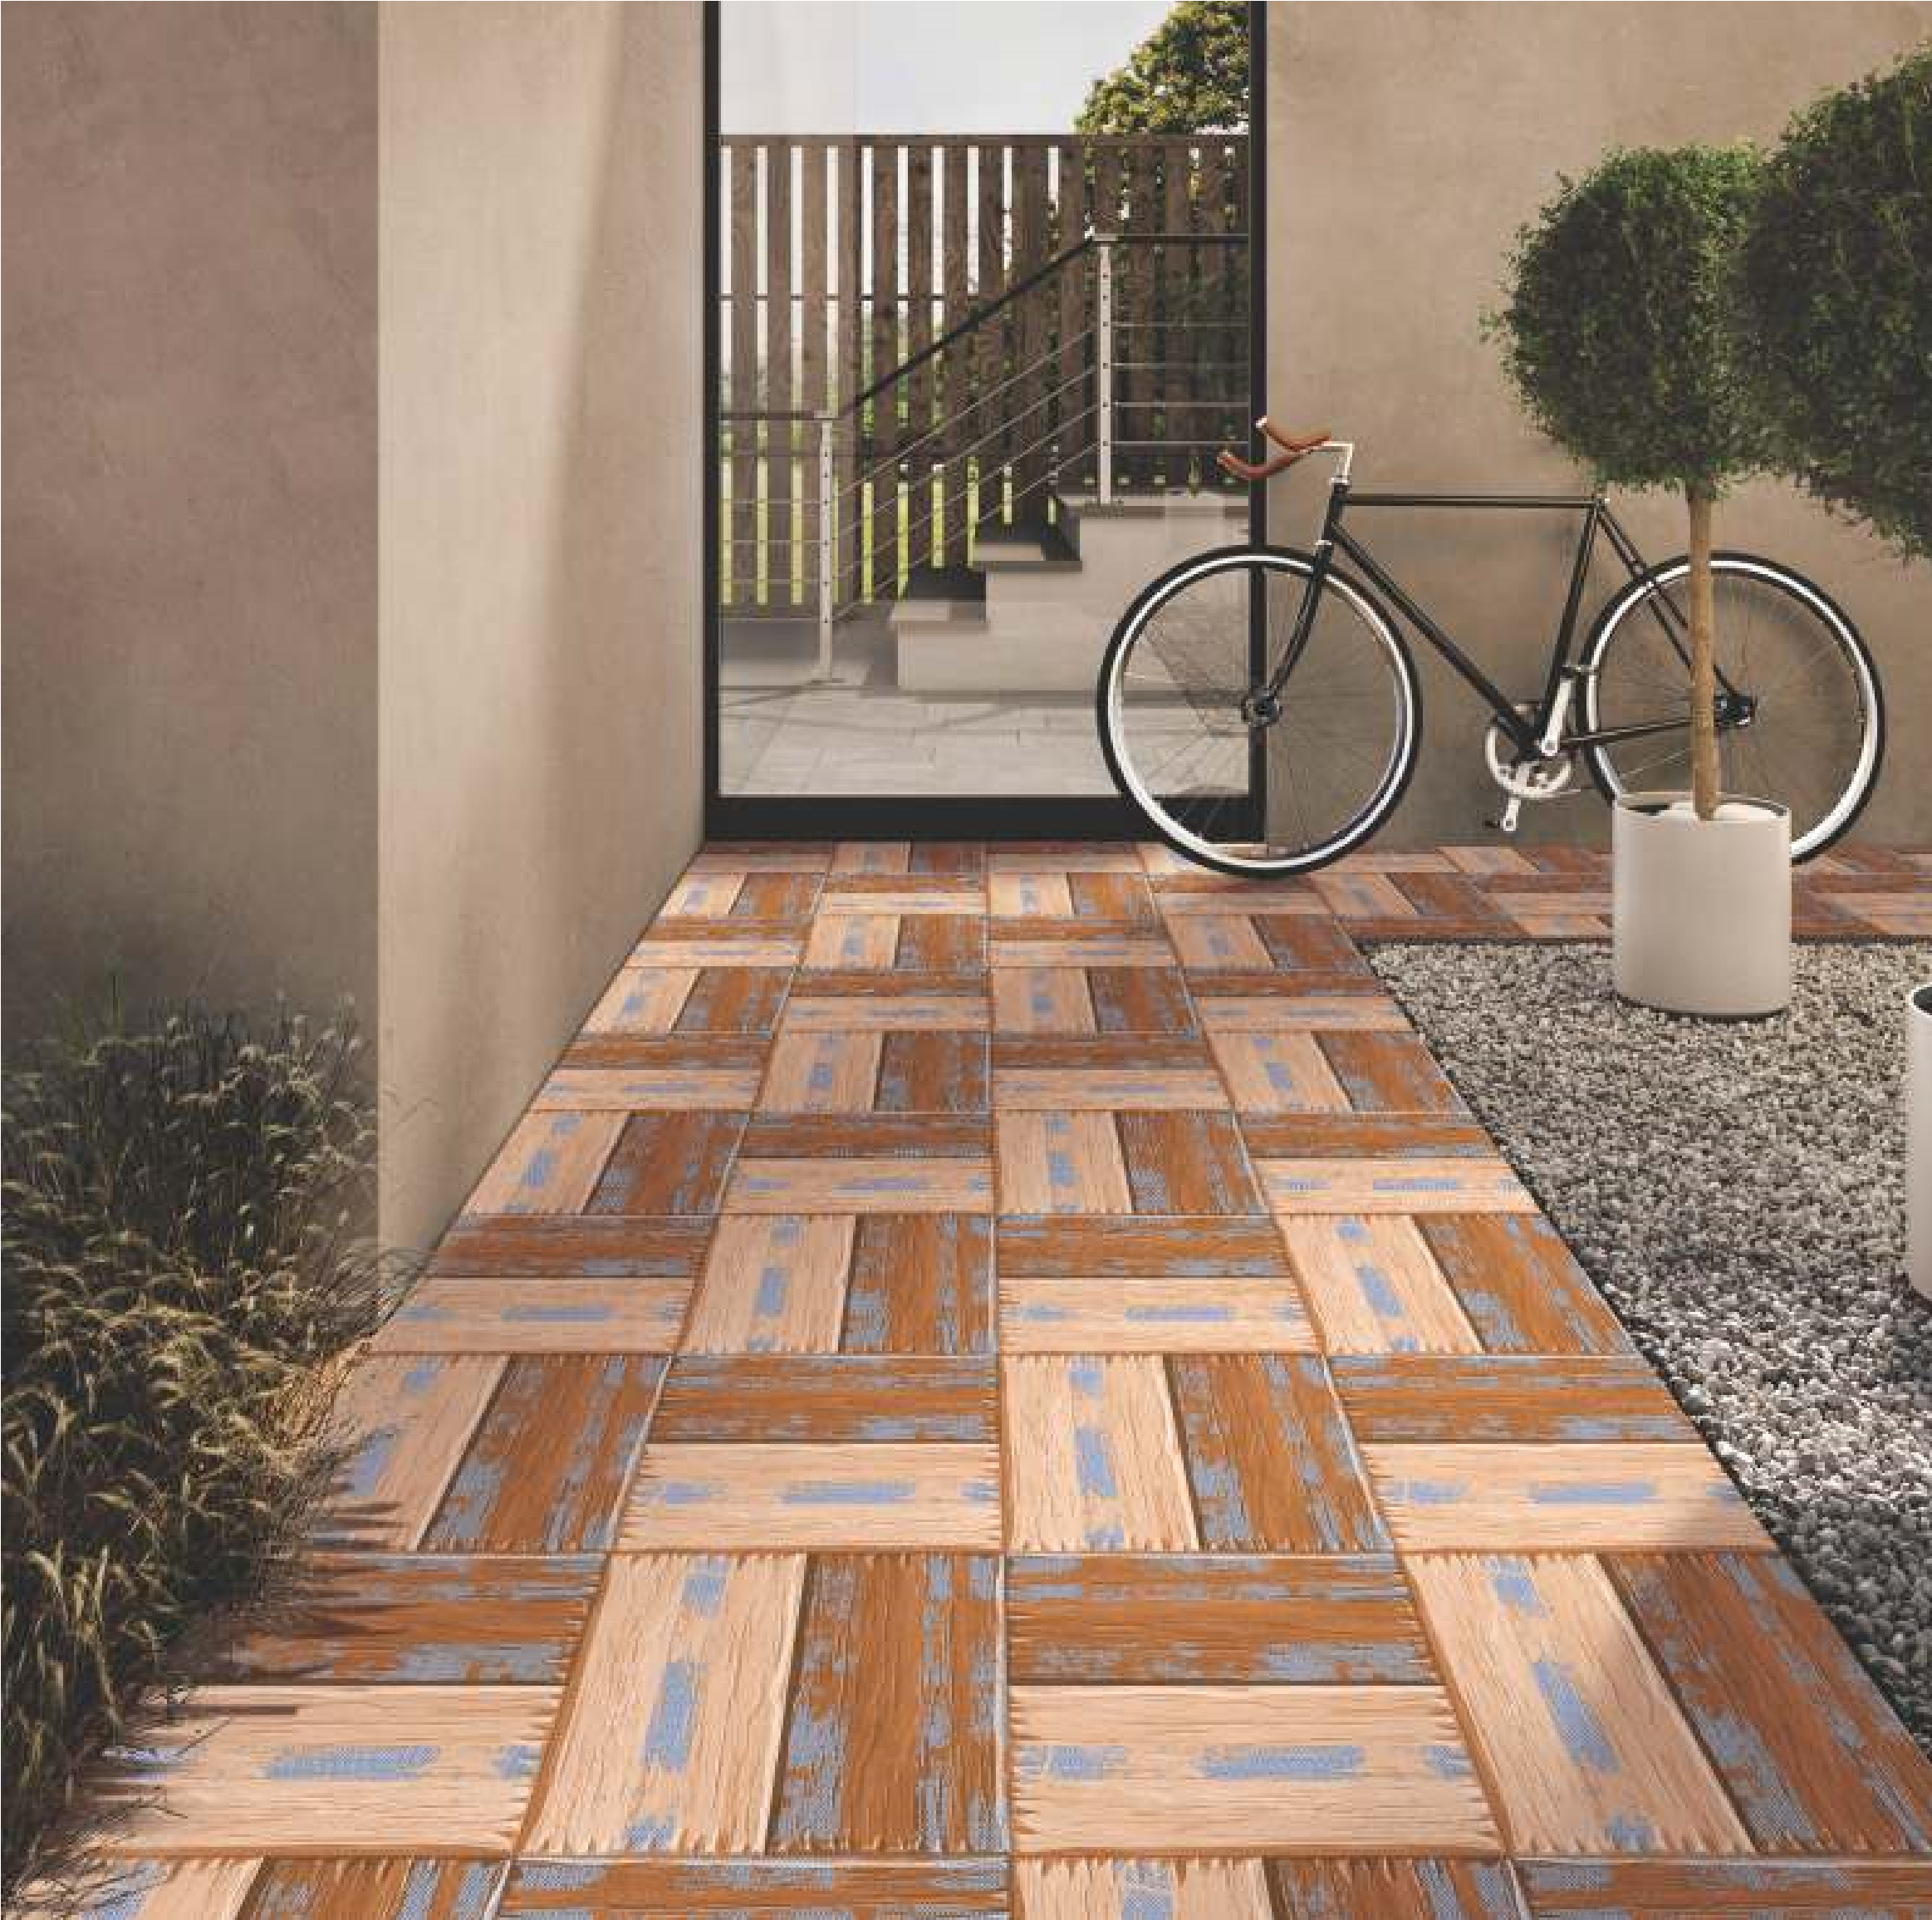

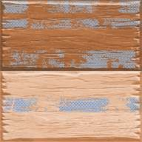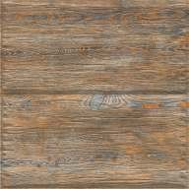

Bosco Wood Nova

Bosco Wood Natural

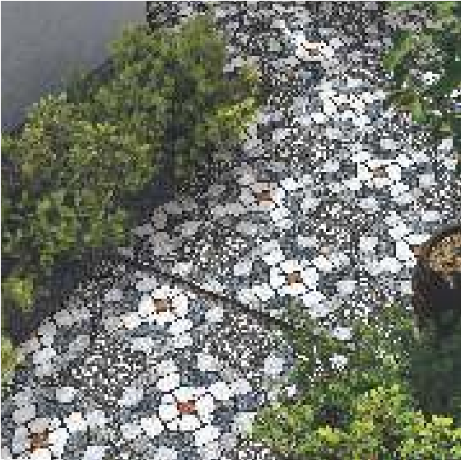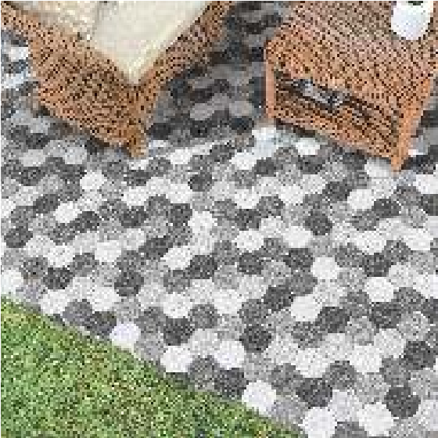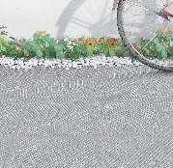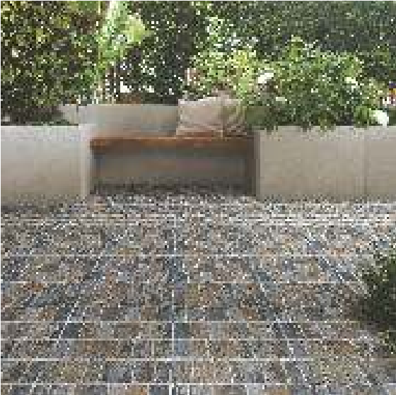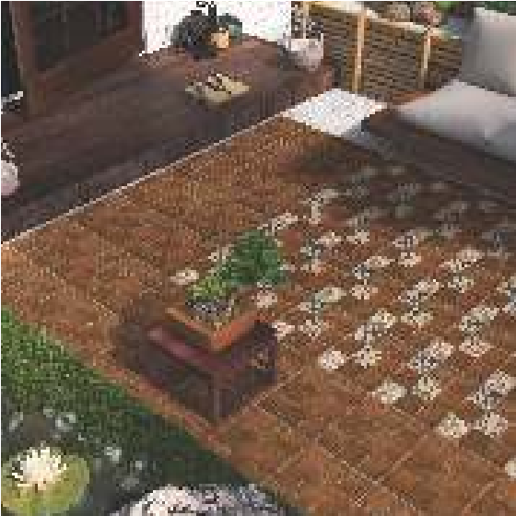

**APPLICATION** **AREAS** :

Exceptional Designs & colors

Ceramic Tiles can be use safely used in all internal and external spaces

That are exposed to high load and pedestrian traffic.

They are flawless Blend of elegance and durablility . Maintaining all

The viral parameters namely surface hardness (Mor).

Water absorption , breaking strength (Mor) load Bearing Capacity etc.

They are safely used on Floor Area like pedrestrain traffic ares,

Vehicular movement areas, terraces, balcony

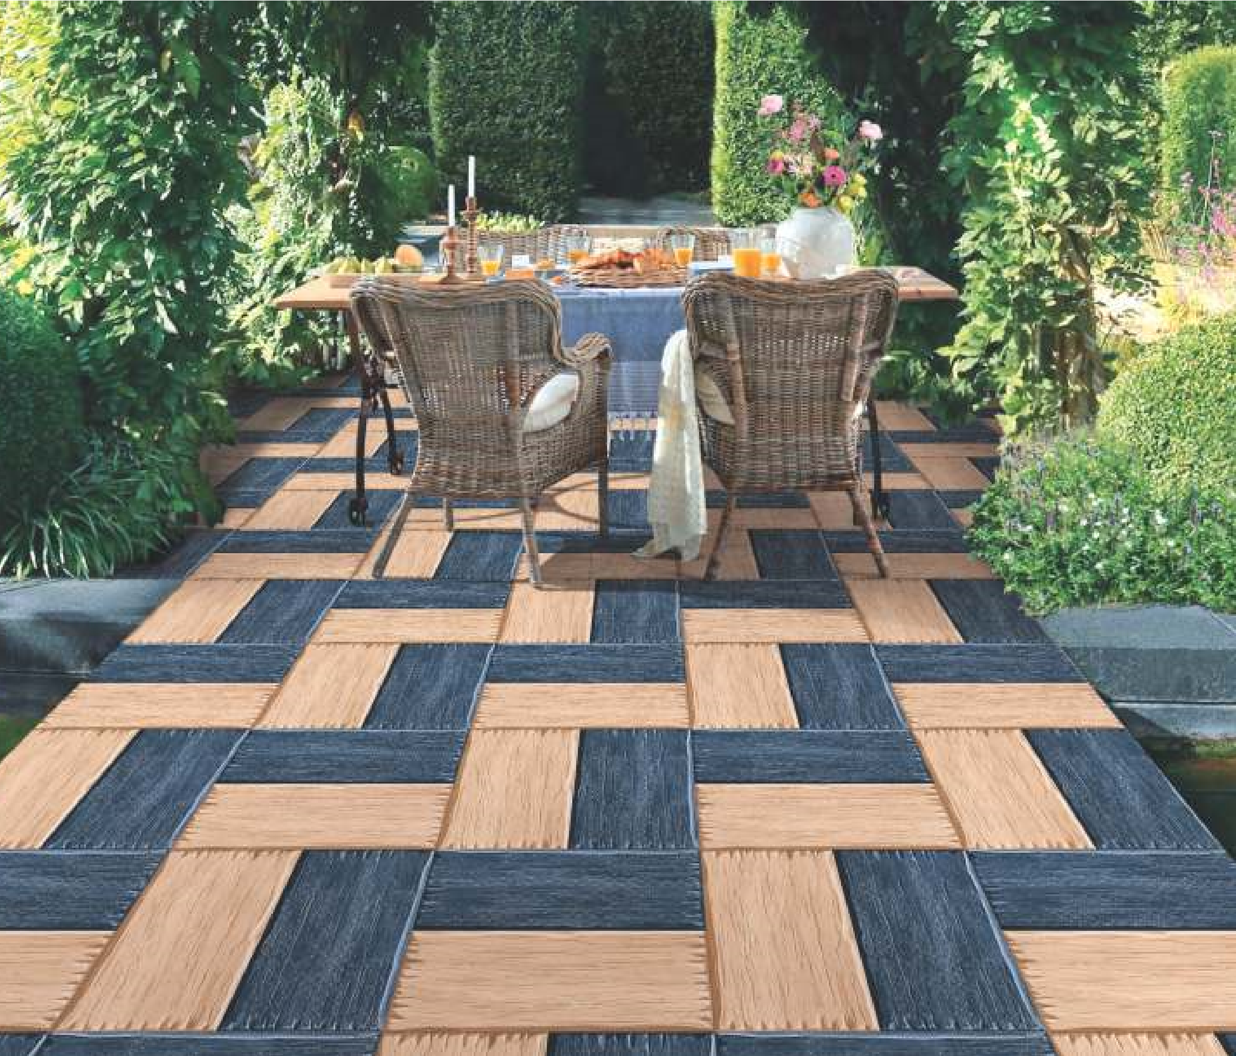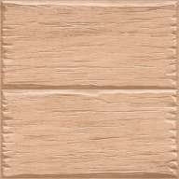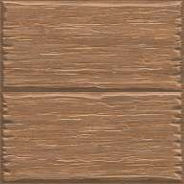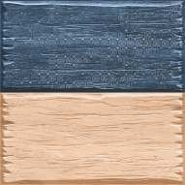

Bosco Wood Marfil

Bosco Wood Blue

Bosco Wood Brown

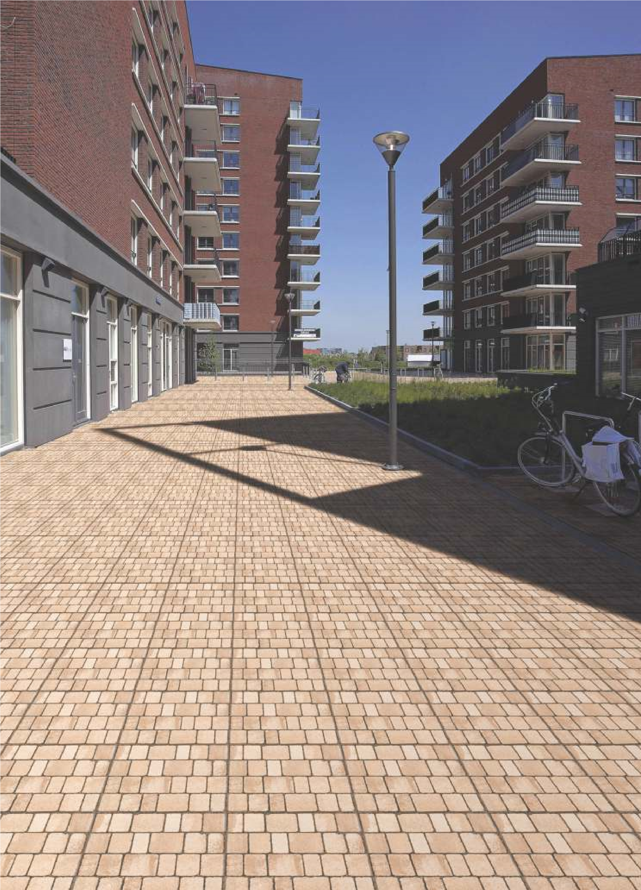­

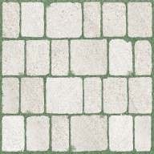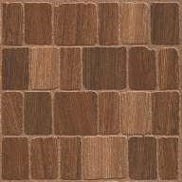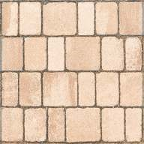

Cobelle Brown

Cobelle Marfil

Cobelle Baanco

**Cera’s**

Tiles Company

**Cera’s Ceramic Limited**

Shop # R-378 SEC 31/B KDA Employees Korangi Karachi.

**May 2022**